ESC 120 Section 51 Introduction to Engineering Design, Spring 2021

Aidan Jackson, Gary Montgomery, Greg Pastor-Hall, Thomas Baher

Dr. Jackie F. Woldering

Lab I – 8 Blinking Lights

Lab Due Date: Sept 6th

# Abstract

The Goal of this lab was to make a complete circuit of 8 LEDs and to write a program that would turn them on and off simultaneously, with delays in between.

# Introduction

This lab experiment helped us to develop an understanding of both circuitry and programming. We learned important concepts such as voltage and the use of resistors, along with programming concepts such as an event loop and code compilation.

# Experiment

We started by picking out the required pieces to complete the circuit:

* 8 LEDs
* 8 Resistors
* 8 Jumper cables
* 1 Jumper cable for GND

We assembled a starter circuit which was a lone LED, then compiled and ran the default “Blink” code provided by the Arduino IDE, also including the pin (2) that we had hooked up to the circuit (See Image I).



We then figured that we could duplicate the data pin – resistor – LED – ground combination for the rest of the LEDs. We started off by trying to assemble an array of four LEDs, but we noticed that the circuit was not working, except for the built-in LED. This confirmed that our code was still running as intended, and we guessed that the circuit was most likely not configured correctly. Following an inspection, we discovered that the polarity of the LEDs was reversed. Once we switched them, the circuit ran as intended (See Image II).



# Results

We were able to prototype and construct a complete circuit, then wrote a corresponding program to control it. We successfully iterated on top of the starting code and circuit to accomplish the goal of simultaneously powering on and off an array of 8 LEDs. Our mistake of reversing the polarity of the LEDs helped to teach us to double check our circuit and taught us the proper way to insert LED legs for future circuits.

# Discussion and Conclusions

Gradually iterating from the starter circuit helped us to modularize the circuit into an array of:

* 1 jumper cable from data pin
* 1 resistor to limit current
* 1 LED (connected to ground)

We then duplicated this “module” four times initially to verify that it worked, then continued to place the other four modules to complete the lab assignment. We may have struggled a bit more and spent more time if we had not iterated and tried to assemble the larger array straight away.

# References

* SparkFun Inventor’s Kit Version 4.1 Guide
  + Used to verify the polarity of LED legs

# Graphics

Image I

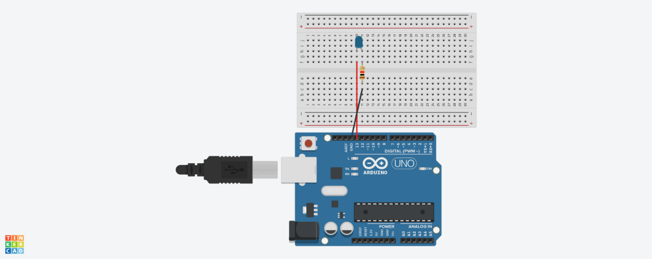

Image II

